**STYLE GUIDE**

**LOGO:**



**Font Style:**

Verdana, Italic

**Font Colours Used:**

AQUA:#[00FFFF](https://www.quackit.com/html/html_editors/scratchpad/?app=color_tester&hexColor=00FFFF) 

Black: #000000 

WHITE: #FFFFFF

**Background Colours Used:**

Green: #d6e3bd 

Yellow: #FAEDB9 

Black: #000000 

WHITE: #FFFFFF

**Transition Effects:**

Background of nav bar changes to black when hovered over them

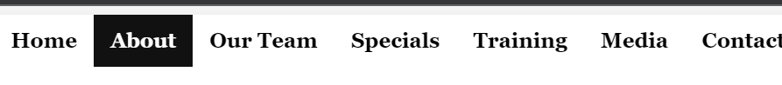

**Forms:**

**Question/query form**

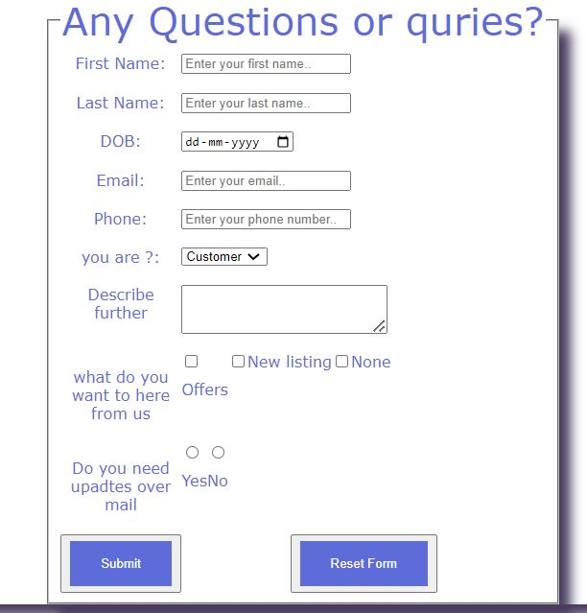

**Buttons:**



**The link: -** [**http://185.113.4.41:7250/index.html**](http://185.113.4.41:7250/index.html)

**My Product: -** MIXERS

**Name: -** Balvinder Singh Sardar

**Student No: -** C0877495